**EMBARGOED UNTIL 9AM, TUESDAY 15TH NOVEMBER, 2022**

UK Cavernoma charity works with renowned designers to create Chelsea Flower Show garden
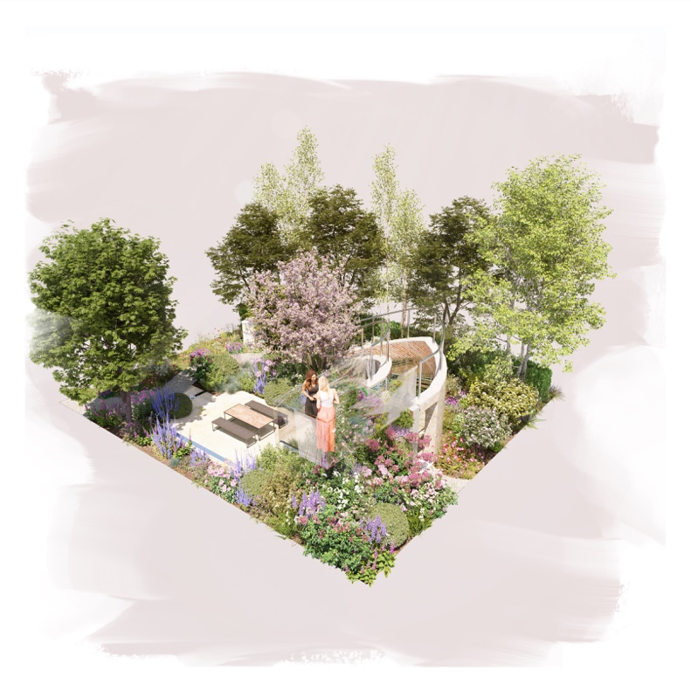

London - November 15, 2022 - The Cavernoma Society, a UK-based charity supporting those affected by cavernoma, will have a garden at the prestigious RHS Chelsea Flower Show, 2023 - raising awareness of this rare neurological condition globally and taking users on a sensory journey depicting the daily symptoms cavernoma patients live with.

The Cavernoma on My Mind -garden, designed by Chelsea favourite, the renowned Taina Suonio, and her friend and colleague, Anne Hamilton, will sit in the Sanctuary space, and consist of named areas which are used to describe feelings of the cavernoma patients, like Fragility of Life, Unconditional Love and Fresh Start.

A cavernoma is a rare lesion most commonly found on the brain or spine made up of thin, abnormal blood vessels which can leak, seeping blood into the surrounding brain and spinal tissue. One in 600 people are affected by cavernoma, but only 1 in 400,000 experience symptoms, thus making it a rare condition. Symptoms include, but are not limited to, strokes, seizures, neurological deficits, disability, and rarely death. The condition can be sporadic (one-off), or genetic, with the familial version becoming more and more prominent.

The charity wants to truly convey the debilitating nature of this condition, its life-changing effect, and the symptoms it can cause, as well as the positives that have come from building a supportive community, offering alternative treatments and support to our members, and showing them a way forward. Therefore, it will ask members to get involved and be part of the garden, by sharing their story.

HEALING NATURE
The plants in these named areas have been chosen for symbolism describing the cavernoma or the feelings a patient goes through, or for the plants’ healing quality stemming from spirit-lifting beauty.

For example, Acer griseum, commonly known as Blood-bark maple represents the thin blood vessels that make up cavernomas and its peeling bark symbolises the fragility of life. Yew (Taxus baccata) cushions in different sizes represent the stages of cavernoma and the prickly foliage describes the shooting nerve pains that patients suffer from. The dark flowers e.g. Rosa Nuits de Young and Aconitum napellus denote the despair and fear of death that cavernoma sufferers feel.

Nature is a healer for many people with cavernoma, who go through various periods of hardship with varying degrees of severity and even a single plant can have an impact on well-being and support a healing process. For example, the beauty of peonies (Paeonia officionalis and lactiflora) in the garden awakens positive feelings but they are also part of this garden for their root extract’s remarkable medicinal qualities against epilepsy and seizures. Of course, the garden would not be the same without raspberries, as the logo of the Cavernoma Society is the raspberry.

SANCTUARY OF BIODIVERSITY
The glass steps ascending to the viewing platform symbolise hope for progress and optimism required for living with the condition. The viewing platform represents security and clarity of vision into the future. The water feature which flows gently down a wall and amidst the plants through the garden denotes on one hand the tears of anxiety and pain shed by the patients, and on the other, the calming effect of letting your emotions out. Altogether, the complete garden, a sanctuary of biodiversity full of symbolism is an outlet for the patients’ feelings as well as awareness-raising about the condition.

“It’s such an honour and a privilege to be part of the RHS Chelsea Show, 2023. This world-renowned gardening show will give us the platform to raise awareness of cavernoma on a global scale, which we know is incredibly important for our members, who are often faced with frustration and anxiety when they tell doctors or friends about their condition and they’ve never even heard of it. By raising awareness we’ll not only be able to help our members feel heard, but we’re opening doors for ground-breaking research into the condition and educating medical professionals in order to better support our members. This has been our aim from the very beginning when we founded The Cavernoma Society, however the show will give us a massive platform to raise awareness which otherwise may take us years,” said Simona Stankovska, founder of The Cavernoma Society.

“We’re delighted to be working with the incredibly talented designers Taina Suonio and Anne Hamilton, who Simona Stankovska, our founder, has worked with in the past. It’s remarkable how our worlds have connected, as Taina herself suffers with debilitating headaches, so therefore understands how most of our members feel, whilst Anne’s family are affected by Cavernoma. Therefore, our Cavernoma on My Mind -garden has been designed with love, passion, and understanding for the condition,” she added.

Taina Suonio has been taking part in The RHS Chelsea Flower Show for the past 18 years. This will be her fourth garden at the show, with her garden from the last three years securing the Silver Gilt medal.

Taina is an internationally awarded landscape designer, horticulturist, MSc. environmental biologist and researcher in the Fifth Dimension - Vegetated Roofs in Urban Areas research group of the University of Helsinki. Her research concentrates particularly on the environmental change and policy with regard to vegetated roofs in urban areas.

Gardening has been Anne’s life for the past 17 years. She has designed and built two award-winning show gardens at Bloom in the Park, Dublin, Ireland. During the past 8 years she’s worked for world renowned designers at the RHS Chelsea Flower Show gardens including: Taina Suonio, Mark Gregory, Nigel Dunnett and Adam Frost.

“I am absolutely thrilled and personally touched to work on this inspiring theme, which has released my creative spirit like never before. We had a fantastic time designing this garden”, says Taina.

The garden will be built by landscapers Tom Salmon Landscaping Ltd, and The Cavernoma Society will look to donate the garden to a neurological hospital after the show.
**ENDS**

For more information, photos, or an interview, please contact
Simona@cavernomasociety.org.uk
www.cavernomasociety.org.uk
Instagram: cavernoma_society
Facebook: CavernomaSociety

Taina Suonio:
www.rmgardens.fi
Instagram: tainasuonio
Facebook: taina suonio
Twitter: @Taina_RMGardens
LinkedIn: Taina Suonio

Anne Hamilton:
www.foxgardens.com
Instagram: anne_hamilton_gardens
Facebook: anne hamilton designs
Twitter: @AHGardenDesign
LinkedIn: Anne Hamilton

